

Name :  **Peter Sunny Shanthveer Markappa**

Subject : **Machine Vision**

Student No. : **R00208303**

Submission Date : **29th April 2022**

University :  **Munster Technology University, Cork, Ireland**

Index

Introduction of Image

1. Task 1
2. Task 2
3. Task 3

**TASK-1-AB**

When a high-resolution object is displayed on a low-resolution display, the imperfections caused by information loss are referred to as aliasing. This can be seen in geometric objects, vector graphics, vector fonts, and 3D graphics. When a smooth object, such as a line, appears jagged because the pixels are large enough to be seen with the naked eye, this is the most common type of visual aliasing. Anti-aliasing techniques, such as adjusting a pixel's color or transparency based on how much of it is covered by the object, can help to mitigate these effects (sub-pixel rendering).

|  |  |
| --- | --- |
|  |  |
|  |  |
|  |  |

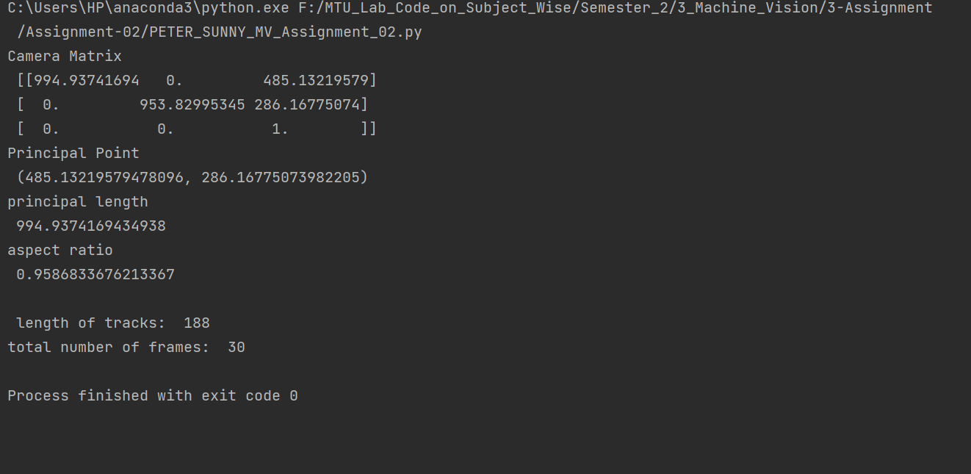

**TASK-1-CD**

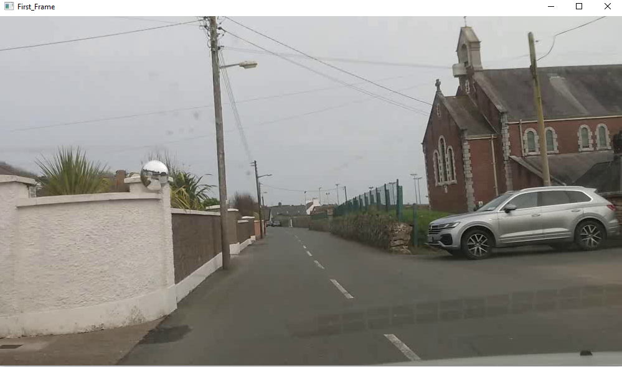

|  |  |
| --- | --- |
|  |  |
|  |  |
|  |  |
|  |  |
|  |  |
|  |  |
|  |  |
|  |  |
|  |  |
|  |  |
|  |  |
|  |  |
|  |  |
|  |  |
|  |  |
|  |  |



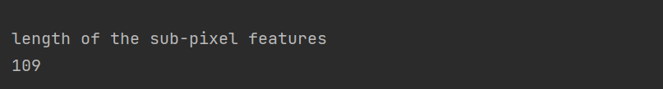

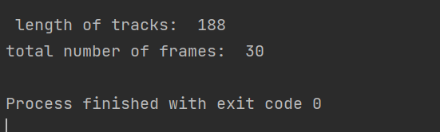

**TASK-2**

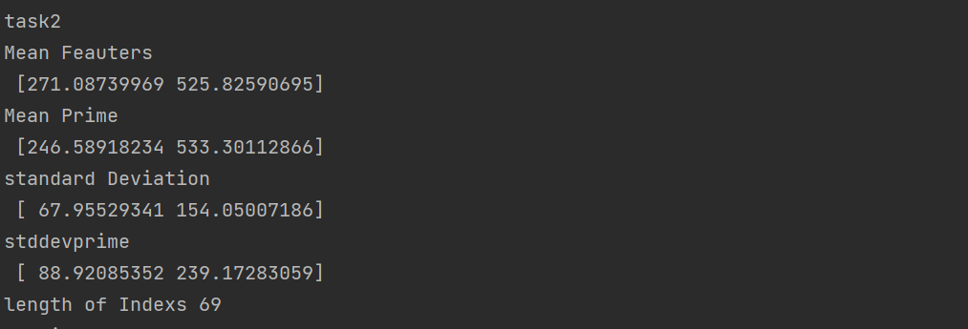

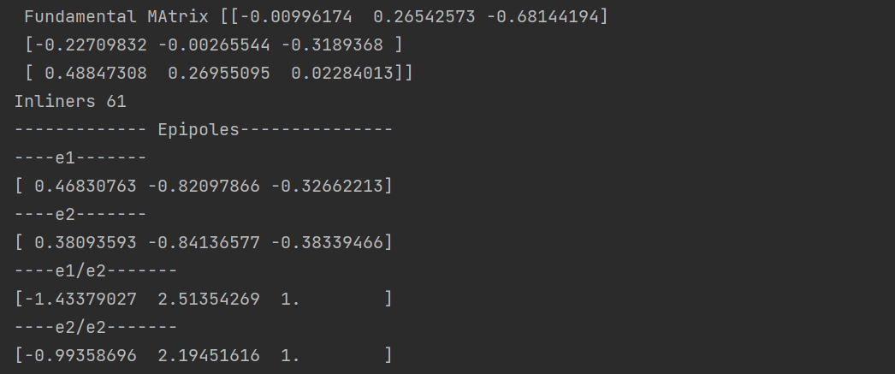

------------- Epi poles linear ---------------

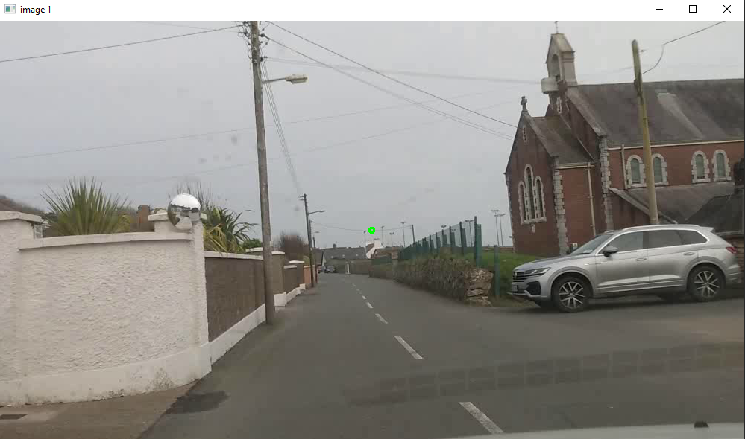

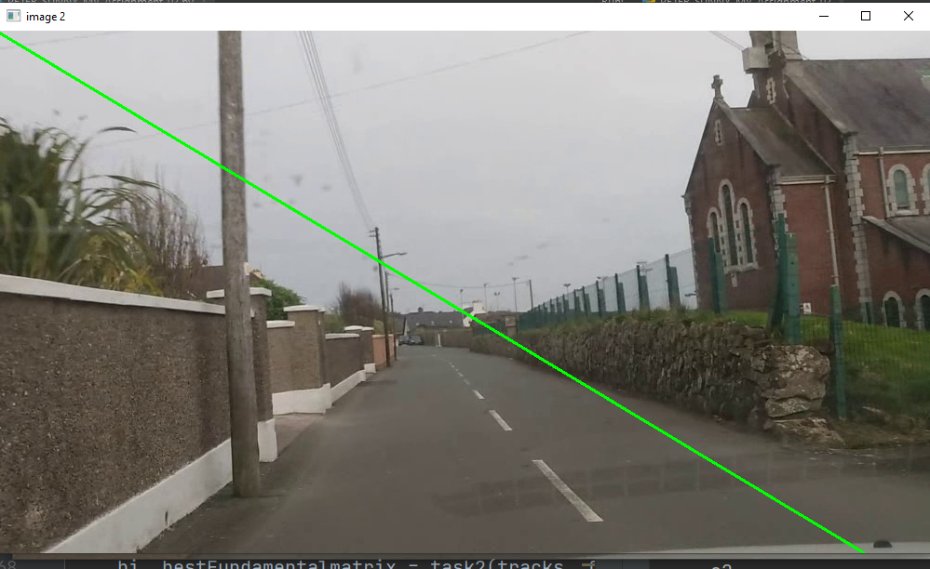

**TASK-3**

